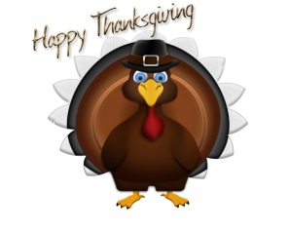

Our Lady of the Presentation Catholic School
Service Team Sack Mass – Wednesday, November 12, 2025

Dear OLP Parents/Guardians and Students,

The annual OLP Sack Mass will be held on Wednesday, November 12, 2025, at 8:15 a.m. This is an event in which we ask each student to fill a grocery bag from home with items and bring it in to school. Service Team students will be at drop off in the morning to assist students with carrying their bags. After Mass the bags will be taken to Lee’s Summit Social Services and given as a donation to serve those in need. This year Lee’s Summit Social Services is providing food to more families in our community than ever. Let’s do our part to ensure no one in our community goes hungry. This is a wonderful Mass to attend. You are able to witness the true meaning of giving and thank God for our many blessings; we invite you to join us.

Below is a suggested food item for each grade level; this is based on Lee’s Summit Social Services’ urgent needs:

- Kindergarten – Pasta

- 1st grade – Oatmeal

- 2nd grade – Cereal

- 3rd grade – Canned meat – Tuna, Chicken, Etc.

- 4th grade – Canned pasta – Spagettio’s, Etc.

- 5th grade – Pasta Sauce

- 6th grade – Canned fruit and vegetables

- 7th grade – Canned soup

- 8th grade – Peanut butter and jelly

Lee’s Summit Social Services is very grateful for our donations and continued support. This is a wonderful way for our students to give back to our community through service.

The Service Team joins me in thanking you for your time and commitment to serving families in our community. May you all have a happy Thanksgiving!

Blessings,

Kelley Pierson,
School Social Worker
Our Lady of the Presentation

